# PHP / AngularJS Challenge – Currency convertor

We would like to create a new currency convertor widget that can sit on any site. It needs to show the amount of foreign currency you would get if you use the WeSwap service compared to the high street or airport.

We will be using the Currency API from ExchangeRates <https://github.com/hippasus/ExchangeRates>

This challenge shouldn’t take more than 2 hours. If you run short of time please just explain what you would have done to complete the challenge. We are looking for well written working code that is the same level as you would produce for a production environment.

Please also list the tests that you would write to test the code.

### Currency convertor requirements

* Backend to be written in PHP
* Calls to the Currency API should be cached for 15 minutes
* The WeSwap service charges 1% above the exchange rate
* This should be compared with 5% on the high street and 11% at the airport
* Users should be able to test converting between any of the following currencies:
  + GBP
  + EUR
  + USD
* The frontend should be written using AngularJS
* The system should be able to withstand the Currency API going down
* Below is a mock-up of how the widget should look   
  (please note: the amounts below are not accurate)

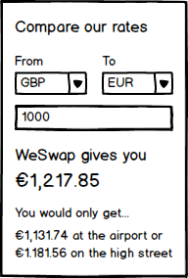

### Extra Challenge

* Scrape the exchange rates off the Travelex website (http://www.travelex.co.uk/uk/personal/rateslist.aspx) and add this to the comparison
* The scraped rates should only be retrieved once a day and then cached

Good luck!